1. [20 points] As blood moves through the heart, what is the last valve it passes through before it goes to the lungs?

The right ventricle contracts and ejects the blood out to the pulmonary arteries to the lungs through the pulmonary semilunar valve (pulmonary valve in figure below).

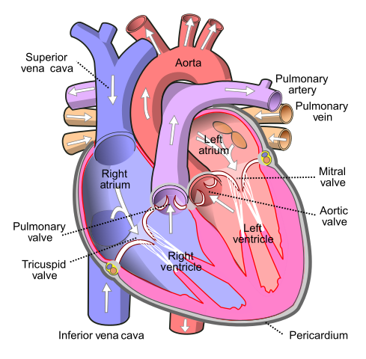

**Fig. 1**: diagram of human heart by Wapcaplet - Own work, CC BY-SA 3.0, <https://commons.wikimedia.org/w/index.php?curid=830253>

1. [20 points] What would be the effect on the Wiggers diagram for the left heart of a reduction in effective cross-sectional area of the aortic valve by a factor of 5 (this sort of reduction in cross-sectional area is referred to as aortic stenosis)? Explain/discuss briefly.

As the cross-sectional area of the aortic valve is reduced by a factor of 5, the pressure gradient across the aortic valve during ejection can become quite high. Due to the narrowed aortic valve, the heart has to work harder to eject blood into the aorta and less blood flows into the aorta compared to a “normal” heart. This leads to an increase in afterload, a decrease in stroke volume, and an increase in end-systolic volume. The reduced output from the left ventricle decreases the aortic pressure.

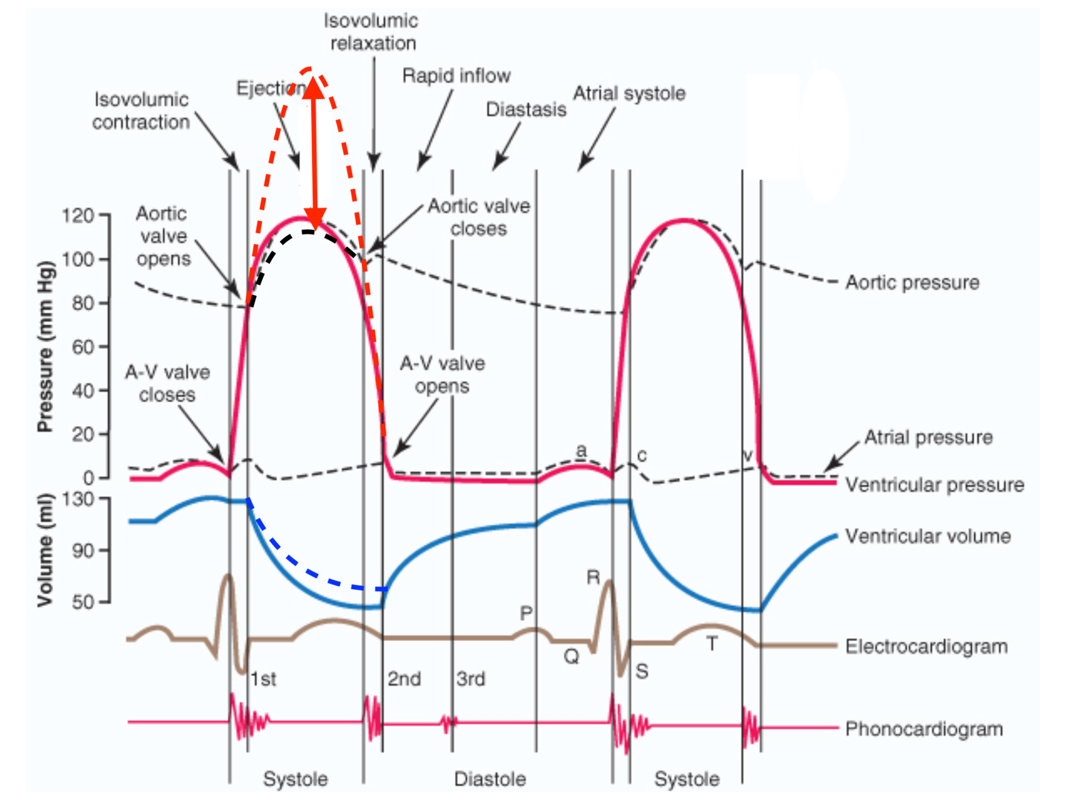

**Fig. 2**: Effects of aortic stenosis on left ventricle and aortic pressures: increased ventricle pressure (dashed red line) and decreased aortic pressure (dashed black line). In vertical red arrow: increased pressure gradient across aortic valve, also end-systolic volume is higher.

1. [20 points] What would be the effect(s) on a left ventricular pressure-volume loop of an increased afterload, assuming preload and ventricular contractility remain the same? Explain/discuss briefly.

Assuming preload and ventricular contractility remain constant, if afterload is increased, the ventricle needs to generate a higher pressure to overcome the aortic diastolic pressure prolonging the pressure isovolumic contraction phase. The ejection will start at a higher aortic diastolic pressure. Constant preload implies constant end diastolic volume. The PV loop compared to the “normal” PV loop stretches more vertically along the LV pressure axis. Also compared to the “normal” heart, the end-systolic volume is increased, therefore the stroke volume and stroke work are reduced.

The end-systolic volume is increased due to the increased afterload and reduction of the velocity to which the blood is ejected from the left ventricle resulting in a decreased ejection fraction.

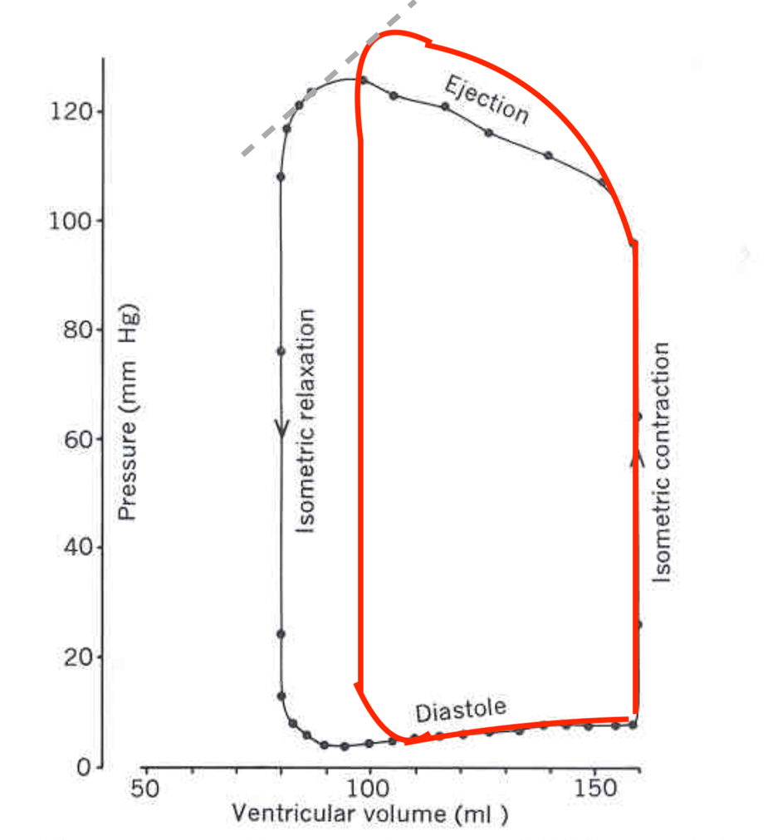

**Fig.3:** PV loop of increased afterload in red compared to “normal” left ventricle when preload and ventricular contractility remain constant (original figure from module 7, video 2, slide 3).